Report of the Program

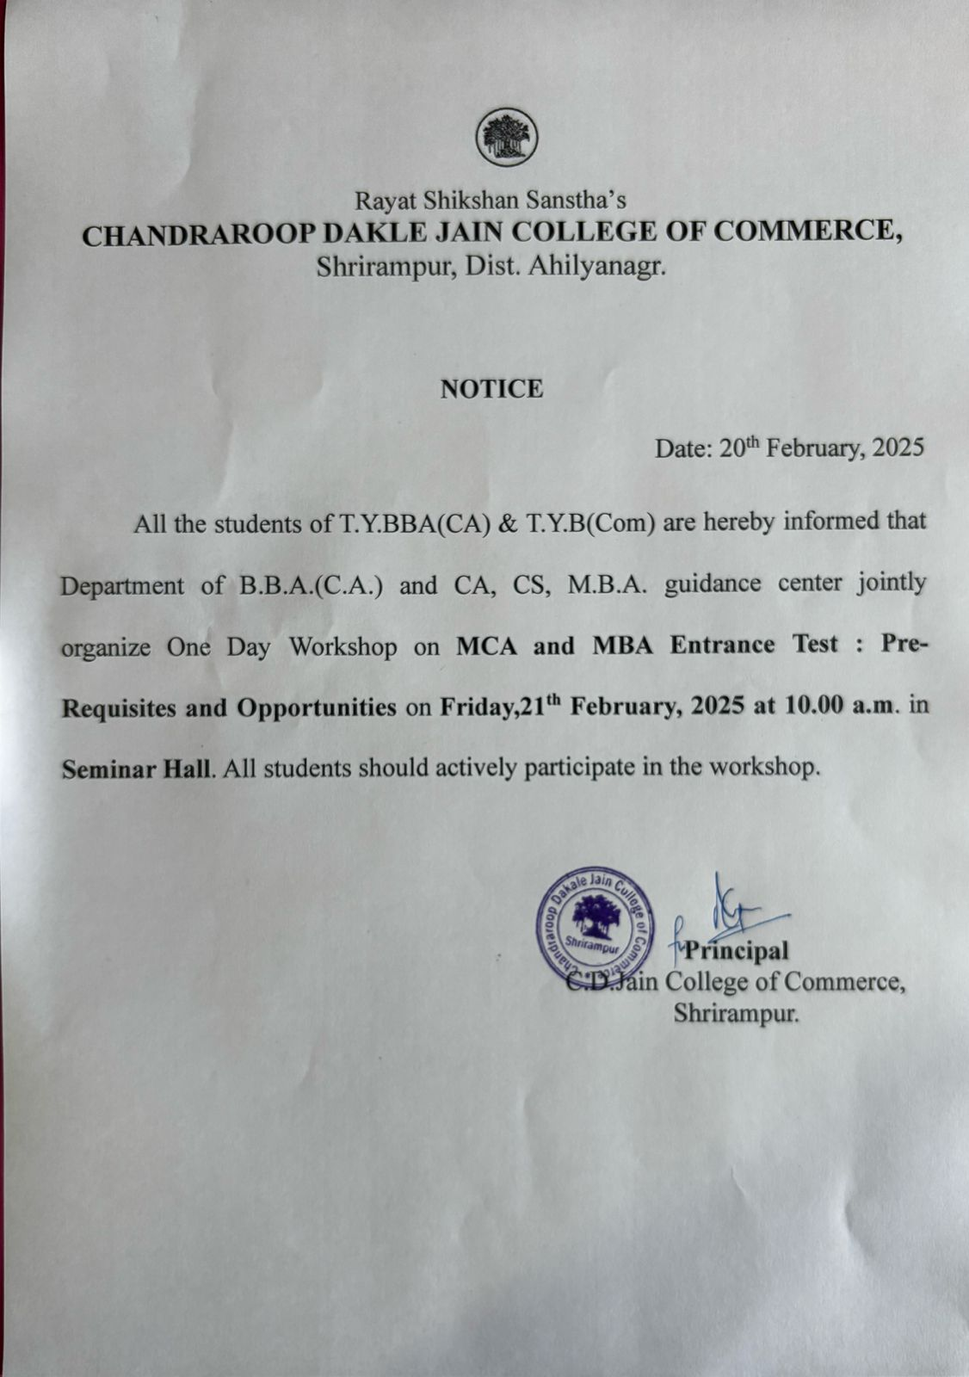

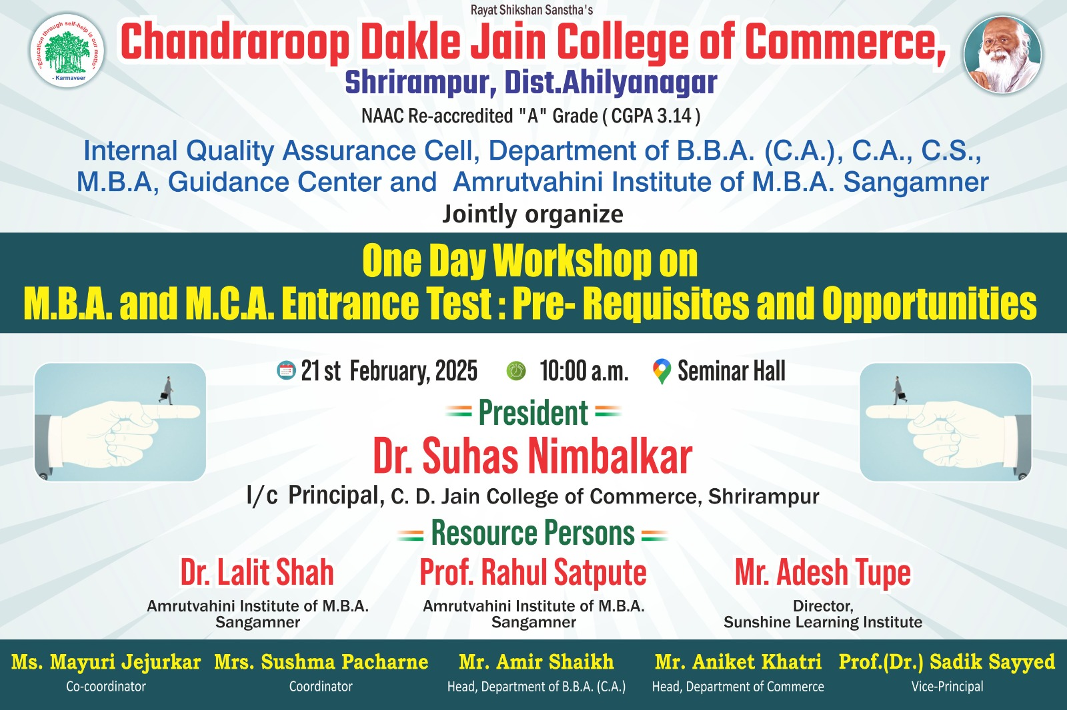

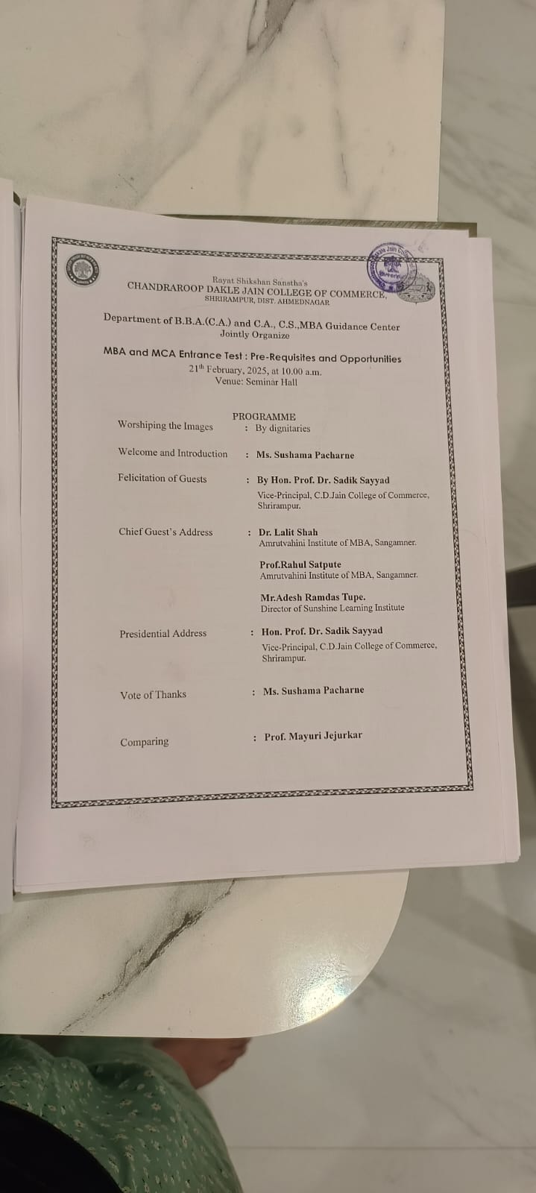

Rayat Shikshan Sanstha’s
CHANDRAROOP DAKLE JAIN COLLEGE OF COMMERCE, SHRIRAMPUR
ACADEMIC YEAR: 2024-25
Internal Quality Assurance Cell, Department of B.B.A. (C.A.), C.A., C.S., M.B.A, Guidance Center and Amrutvahini Institute of M.B.A. Sangamner
Report of the Programme

S.N. | Particulars | Responses
1 | Title of the Event | One Day Workshop on M.B.A. and M.C.A. Entrance Test: Pre-Requisites and Opportunities
2 | Date and Time | 21st February, 2025 at 10.00 A.M.
3 | Sponsor/Funded by | C.D. Jain College of Commerce,Shrirampur.
4 | Objectives | 1. Guide for the MBA and M.C.A. CET entrance examination  2. Orient the students with the syllabus and structure of MBA and  M.C.A. CET entrance examination  3. Provide and discuss the old question papers  4. Conduct the mock test
5 | Name of the Expert/Resource Person and Contact | Dr. Lalit Shah  Amrutvahini Institute of M.B.A. Sangamner  Prof. Rahul Satpute  Amrutvahini Institute of M.B.A.Sangamner  Mr. Adesh Tupe  Director,  Sunshine Learning Institute
6 | Outcomes | - Guided students for the MBA and M.C.A. CET entrance examination.  - Oriented students with the syllabus and structure of MBA and M.C.A. CET entrance examination  - Provided and discussed the old question papers  - Conducted the mock test
7 | Number of Beneficiaries - Students | Boys:28 | Girls:76 | Total : 104
8 | Number of Beneficiaries - Staff | Teaching:11 | Non- teaching:01 | Total : 12
9 | Venue | Seminar Hall
10 | Online/Offline | Offline
11 | Name of the Coordinator | Miss. Jejurkar M. S. and Miss. Pacharne S. C.

Co-Ordinator I/C Principal
C. D. Jain College of Commerce

Photographs of the Event

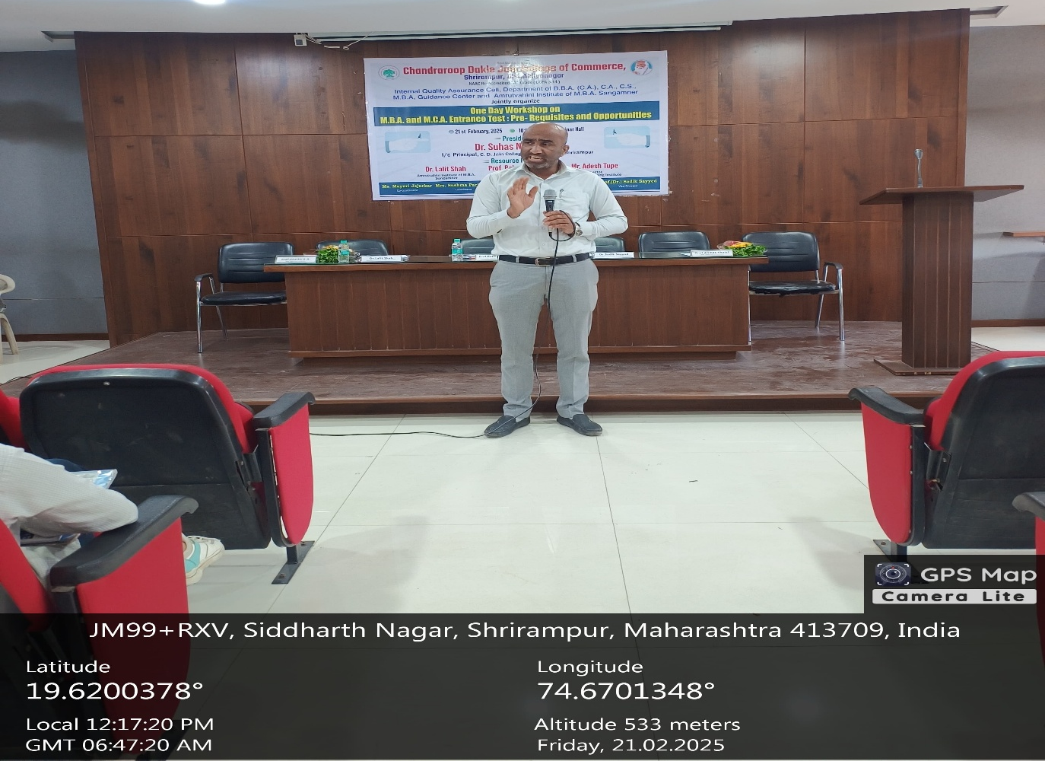
Prof. Rahul Satpute addressing the Students on how to be a successful in Entrance exams
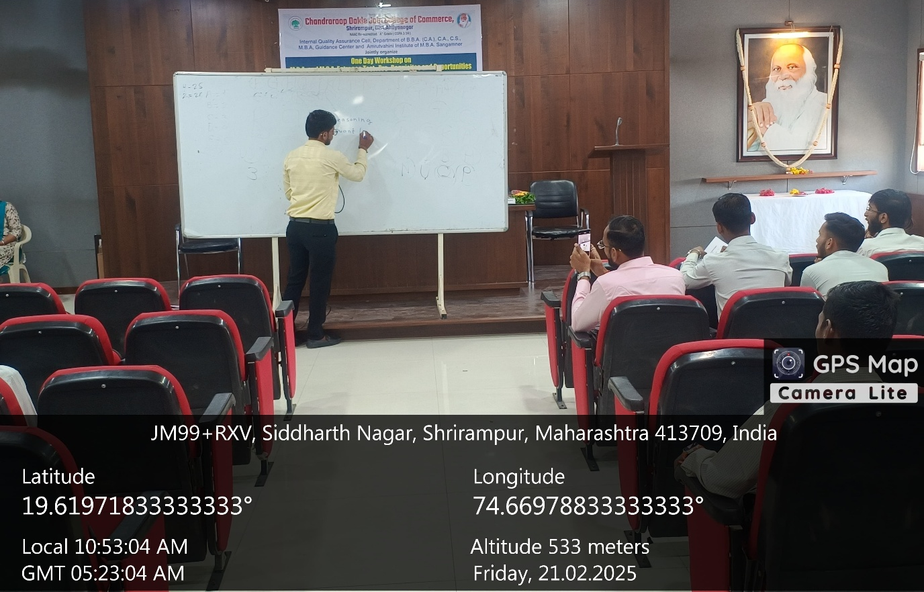

Training Session By Mr. Adesh Tupe

