Curriculum Vitae/ Profile
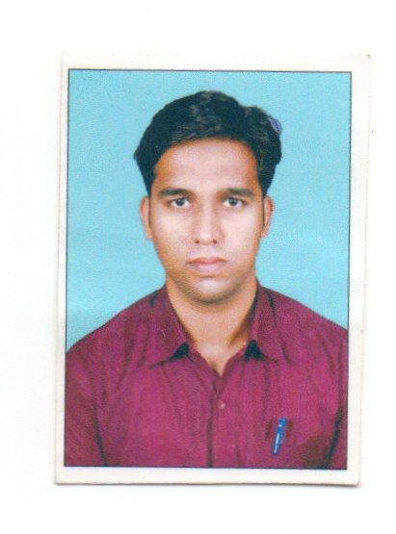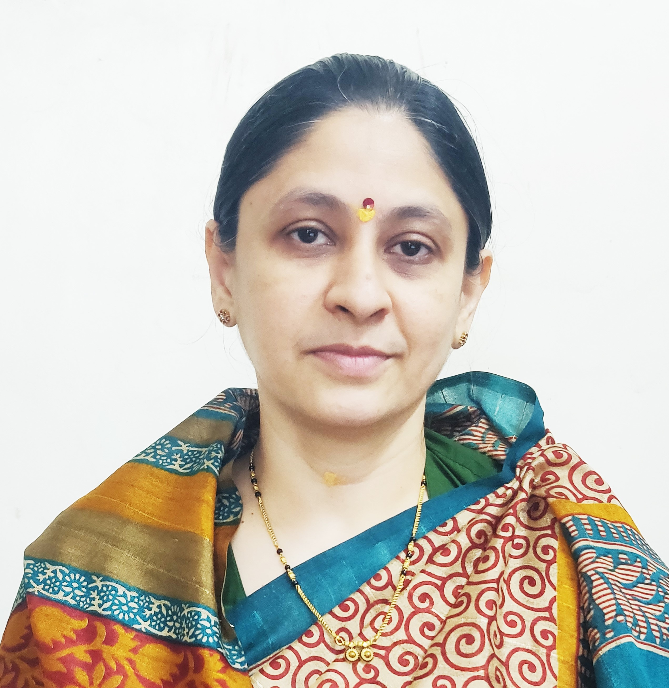
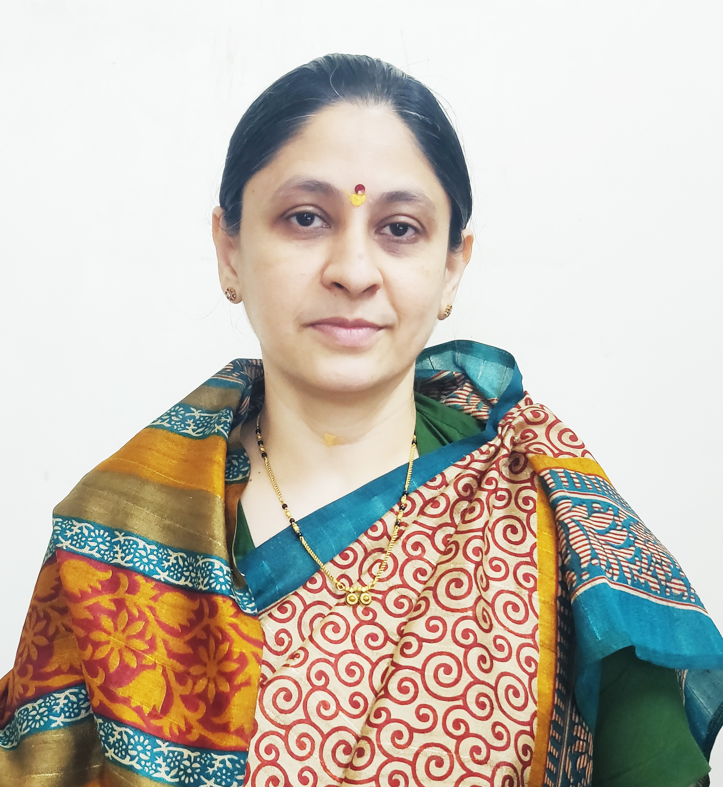

Photo
- General Information:

  - Name : Shaikh Arshad Anwar
  - Designation : Assistant Professor in Commerce

  - Date of Birth : 29th January, 1992
  - Educational Qualifications: M. com, SET (Commerce)

  - Present Pay Scale : CHB Grantable
  - Subject : Commerce

  - Area of Specialization : Advanced Accounting and Taxation
  - E-mail Id : arshads223@gmail.com
  - PAN : GDXPS4239D
  - Phone No. : 8698352353
  - B.C.U.D. Profile Username: 52111800092
  - HRMS Employee Code : NA

  - Permanent Address : Millat Nagar, Ward NO. 1, Shrirampur.

  - Aadhar Card Number : 8479- 8211 -4360
- Academic Qualifications:

Degree | Board/University | YearofPassing | %ofMarks
S.S. C. | Maharashtra Board | 2007 | 63.53%
H.S.C. | Maharashtra Board | 2009 | 69.50%
B.Com. | University of Pune | 2012 | 77.75%
M. Com. | University of Pune | 2014 | 72.56%
SET (Commerce) | University of Pune | 2018 | Qualified

- Teaching Experience (Commerce):

Date of Appointment in Rayat Shikshan Sanstha, Satara | Teaching Experience  (Years) | Research Experience  (Years)
18th June, 2018 | 07 Years | NA
- Details of Services in Sanstha:

Sr.  No. | Name of the College | Period of Service
Sr.  No. | Name of the College | From | To
1. | C. D. Jain College of Commerce, Shrirampur | 18th June, 2018 | Till Date

- I. Research Papers Published:

S.N. | Title of the Paper | Journal | Issue | ISSN No | Page No. | Citations
1 | Study of Corporate Social Responsibility and its Applicability | Education and Society - Indian Institute of Education | I / Volume - III | 2278 -6864 | 329 | UGC Care Listed
2 | The Study of Rural Entrepreneurship and its Promotion | International Journal of Economics, Business, Accounting, Agriculture and Management towards Paradigm Shift in Research (IJEBAMPSR), | 1 / Volume - 2 | 3065-9140 | 80 | -
3 | Study of Accounting Standard on Valuation on Inventory | - | - | - | - | -

II. Articles / Chapters published in books:

Sr.  No. | Title with page no. | Journal | ISSN / ISBN | Impact Factor | Peer Reviewed | Citations
1 | Rashtra Sant Gadage Maharaj – Page No 61 – 17th December, 2022 | Desh Aani Videshatil Vividh Kshetratil Purush KartutwacheYogdaan | ISBN 978-93-91033-77-4 | NA | NA | NA

- Training Programmes attended: (Orientation/ Refresher/ Short Term Courses/ Faculty Development Courses)

Sr.  No. | Theme of Course | Organised by | Duration
1 | Orientation and Sensitisation Programme on NEP 2020 | Dr Babasaheb Ambedkar Marathwada University, Chhatrapati Sambhajinagar, UGC-Malviya Mission Teacher Training Centre | 21st April, 2025 to 30th April, 2025.
2 | Faculty Development Programme in Artificial Intelligence | C. D. Jain College of Commerce, Shrirampur | 16th June, 2025 to 21st June, 2025

VII. Details of Seminars/Conference/Workshops/Symposia attended:
- SEMINARS:

Sr.  No. |  | Theme of Seminar/  Workshop | Organised by | Attended/  Presented Paper | Level | Date
1 | New Trends in Inventory Management |  | C. D. Jain College of Commerce, Shrirampur | Attended | National | 14th to 15th December, 2019
2 | Intellectual Property right & Research Methodology |  | C. D. Jain College of Commerce, Shrirampur | Attended | State | 12th February, 2020

- CONFERENCES:

Sr.  No. | Theme of Conference | Organised by | Attendance/  Presentation | Level | Date
1 | Recent Trends in Commerce, Economics and Management (RTCEM 2025) | SSGM Science, Gautam Arts and Sanjivani Commerce College, Kopargaon | Attended | National level E- Conference | 18th March, 2025

- WORKSHOPS:

Sr.  No. | Theme of Seminar/ Workshop | Organised by | Capacity | Date
1 | One Day Workshop on Research Methodology | C. D. Jain College of Commerce, Shrirampur | One Day | 7th February, 2024
2 | One Day Workshop on NEP 2020 | C. D. Jain College of Commerce, Shrirampur | One Day | 25th June, 2024
3 | One Day Workshop on Masterclass on Development of Growth Mindset | Karmaveer Bhaurao Patil Research Foundation, Satara | One Day | 01st October, 2024

- Papers Published in Conferences Proceedings:

S.N. | Name of the Conference | Title of the Paper | Level | ISSN No. | Place | Pg. No.
1 | Desh aani Videshatil Vividh Kshetratil Purush Kartutwache Yogdaan | Rashtra Sant Gadage Maharaj – Page No 61 – 17th December, 2022 | 23rd International Interdisciplinary Conferrence, Pune | ISBN 978-93-91033-77-4 | Pune | 61

- Lectures Delivered: -

Sr.  No. | Topic of Lecture | Organised by | Programme
1. | Awareness about NEP 2020 | C. D. Jain College of Commerce, Shrirampur -Yashwant High School and Junior College, Padhegaon – (Faculty Exchange Programme) | School Connect 2.0 (Faculty Exchange Programme)

- Any Other Information

  - Centre for Innovation,Incubation and Entrepreneurship Development (CIIED) – Coordinator.
  - T.Y.B.COM. Admission Committee – Chairman.
  - NAAC Criterion VII – Member
I hereby declare that all the information given above is true to the best of my knowledge.

Mr. Arshad Shaikh
DATE: 10th July, 2025 NAME OF THE TEACH

