Curriculum Vitae/ Profile
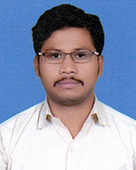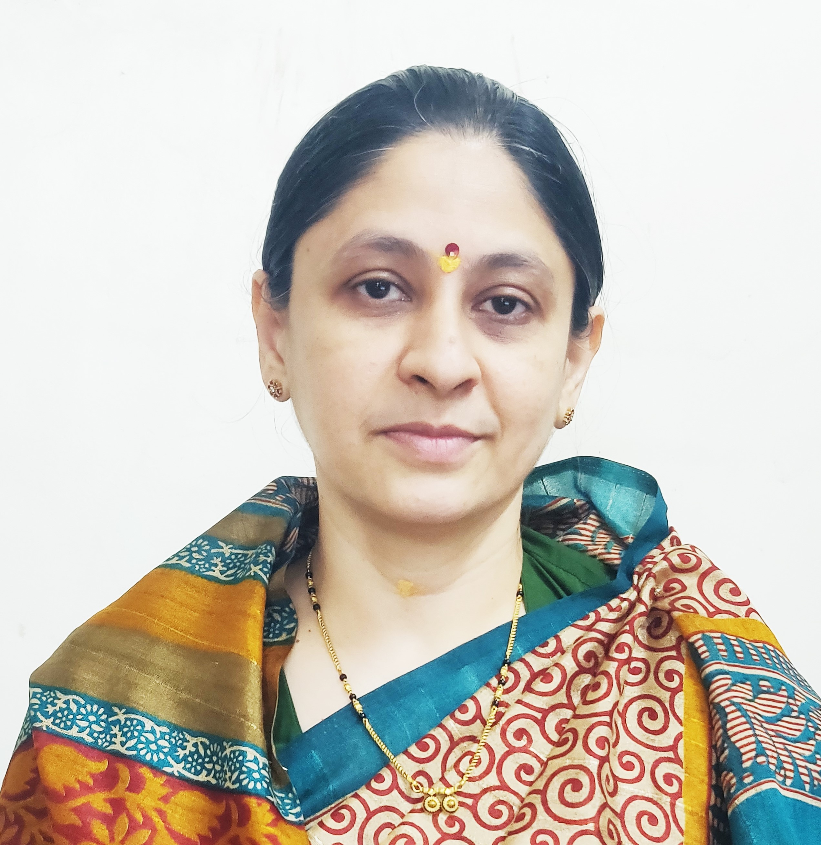
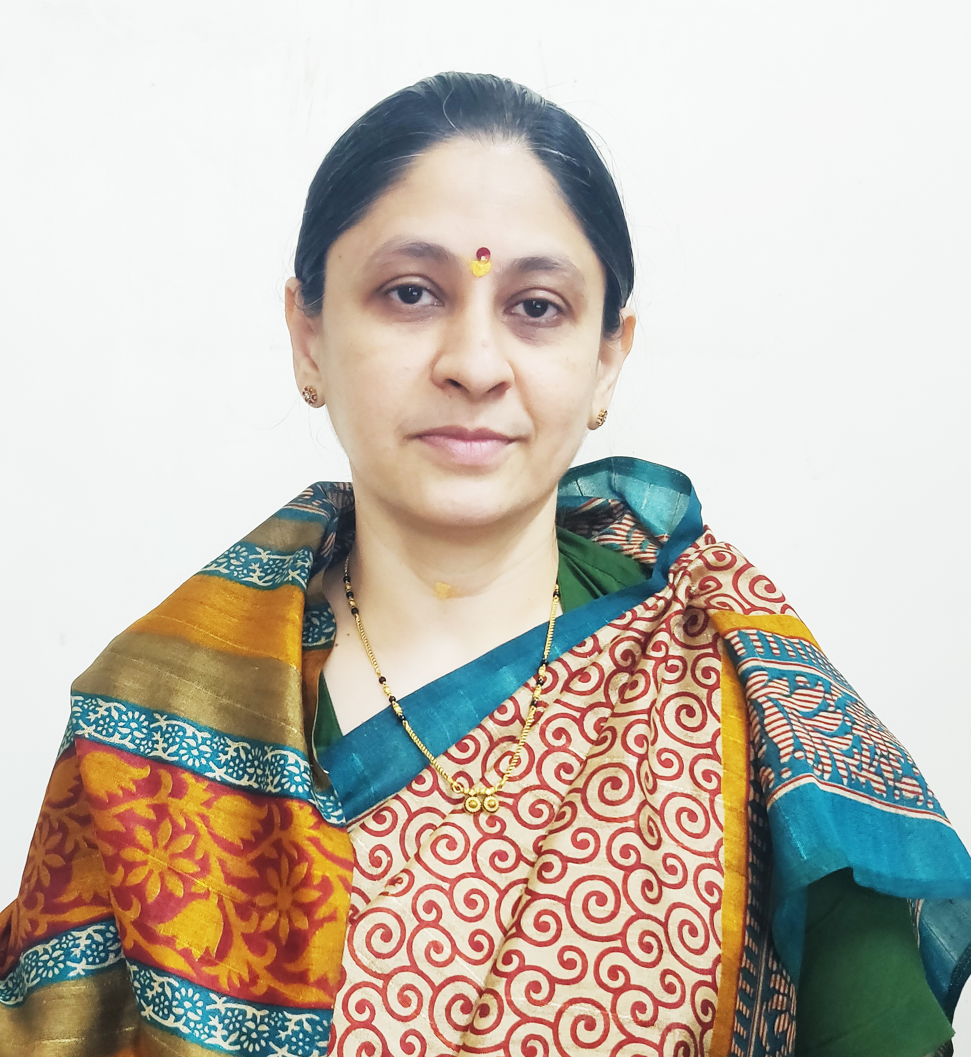

Photo
- General Information:

  - Name : Mr Datir Kailas Raghunath.
  - Designation : Assistant Professor in Commerce

  - Date of Birth : 27/05/1987
  - Educational Qualifications: M. com, SET (Commerce),
  - Present Pay Scale : CHB Grantable
  - Subject : Commerce

  - Area of Specialization : Cost and works Accounting
  - E-mail Id : krdatir@gmail.com
  - PAN : BATPD9254K
  - PhoneNo. : 9822582864
  - B.C.U.D. Profile Username: 52201798354
  - HRMS Employee Code : NA

  - Permanent Address : A/P Nipaniwadgaon Tal-Shrirampur.

  - Aadhar Card Number 803177288972
- Academic Qualifications:

Degree | Board/University | YearofPassing | %ofMarks
S.S. C. | Maharashtra Board | 2002 | 69.73%
H.S.C. | Maharashtra Board | 2004 | 71.00
B.Com. | University of Pune | 2007 | 76.33
M. Com. | University of Pune | 2009 | 71.00
P.G.D.B.M | University of Pune | 2009 | 70.33
G.D.C & A | G.D.C.& A Board Pune | 2012 | 56.6
SET (Commerce) | UGC | 2016 | Qualified

- Teaching Experience (Commerce):

Date of Appointment in Rayat Shikshan Sanstha, Satara | Teaching Experience  (Years) | Research Experience  (Years)
21th July, 2017 | 8 Years | NA
- Details of Services in Sanstha:

Sr.  No. | Name of the College | Period of Service
Sr.  No. | Name of the College | From | To
1. | C. D. Jain College of Commerce, Shrirampur | 21th July, 2017 | Till Date

- Research Papers Published:
S.N. | Title of the Paper | Journal | Issue | ISSN No | Page No. | Citations
1 | To Study the Methods Available For Inventory Management | International Journal of Management and Economics | 27 | 2331-4687 | 22 | Impact Factor – 6.81
2 | To Study the Methods Available For Inventory Cost Control | International Journal of Management and Economics | 27 | 2331-4687 | 24 | Impact Factor – 6.81
3 | E-Commerce in India :Challenges and Opportunities | Strengthening Business Competencies For Sustainable Development | 235B | 2348-7143 | 34 | Impact Factor – 6.625
4 | To Study the Recent Trends in Financial Management | Akshay Kalit – UGC Care listed Journal Humanities social Science and Fine Arts | 9 | 2277-419X | 2944 | -
5 | To Study of Emerging Trends in E-Banking Service in India | Education & Society – 27th – 28th January, 2023 | I/IV | 2278-6864 | 28 | UGC Care Listed

- Articles/ Chapters published in books:

Sr.  No. | Title with page no. | Journal | ISSN / ISBN | Impact Factor | Peer Reviewed | Citations
1 | Me Pahilela Ek Udyojak | Desh Aani Videshatil Vividh Kshetratil Purush KartutwacheYogdaan | ISBN 978-93-91033-77-4 | NA | NA | NA
2 | Me Pahilele Ek Udyojak –Aanand Mahindra | The Contribution of National and International Personalities in The Making of Modern India | - | NA | NA | NA

- Training Programmes attended: (Orientation/ Refresher/ Short Term Courses/ Faculty Development Courses)

Sr.  No. | Theme of Course | Organised by | Duration
1. | Faculty Development Programme in Artificial Intelligence | C. D. Jain College of Commerce, Shrirampur | 16th June, 2025 to 21st June, 2025
- Details of Seminars/Conference/Workshops/Symposia attended:
- SEMINARS:

Sr.  No. |  | Theme of Seminar/  Workshop | Organised by | Attended/  PresentedPaper | Level | Date
1 | NA |  | NA | NA | NA | NA

- CONFERENCES:

Sr.  No. | Theme of Conference | Organised by | Attendance/  Presentation | Level | Date
1 | Akshay Kalit – Transforming Challenges in Business Opportunities | SSGM Science, Gautam Arts and Sanjivani Commerce College, Kopargaon | Attended | International Level Virtual Conference | 29th to 30th March
2 | India @75: Sustainable Development through Commerce and Management | Karmveer Bhaurao Patil Mahavidyalaya, Pandharpur | Attended | UGC CARE Listed Journal - | 27th – 28th January, 2023
WORKSHOPS:

Sr.  No. | Theme of Seminar/ Workshop | Organised by | Capacity | Date
1 | One Day Workshop on Research Methodology | C. D. Jain College of Commerce, Shrirampur | One Day | 7th February, 2024
2 | One Day Workshop on NEP 2020 | C. D. Jain College of Commerce, Shrirampur | One Day | 25th June, 2024
- Papers Published in Conferences Proceedings:

S.N. | Name of the Conference | Title of the Paper | Level | ISSN No. | Place | Pg. No.
1 | Desh aani Videshatil Vividh Kshetratil Purush Kartutwache Yogdaan | Me Pahilela Ek Udyojak | 23rd International Interdisciplinary Conferrence, Pune | ISBN 978-93-91033-77-4 | Pune | 30
2 | The Contribution of National and International Personalities in the Making of Modern India | Me Pahilela Udyojak- Aanand Mahindra | 29th International Interdisciplinary Conferrence, Pune | - | Pune | -
- Participation in Corporate life /Extension work/ Community Services:

Sr.No | Position held | Name of the Authority | From | To
1. | Accountant | Panchayat Samiti Rahuri | 20/07/2010 | 30/04/2016

- Lectures Delivered:-

Sr.  No. | Topic of Lecture | Organised by | Programme
1. | Awareness about NEP 2020 | Aart,commerce and science college,Ashoknagar | School Connect 2.0 (Faculty Exchange Programme)

- Any Other Information
  - NAAC Criterion I – Chairman.
  - Short Term Course Department – Coordinator.
  - Programm Officer National Service Scheme.
I hereby declare that all the information given above is true to the best of my knowledge.

Mr.Datir Kailas Raghunath.
DATE: 10th July, 2025 NAME OF THE TEACHER

