Curriculum Vitae / Profile
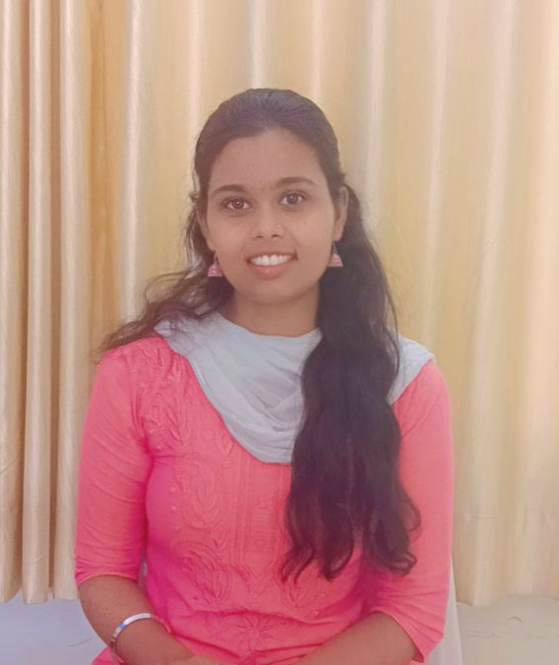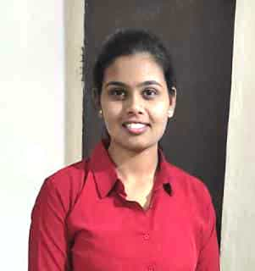

- General Information:

- Name : Miss. Jejurkar Mayuri Shivaji
- Designation : Assistant Professor
- Date of Birth : 10/07/1999
- Educational Qualifications : NET, SET, M. Com
- Present Pay Scale : CHB Grantable
- Subject : Commerce
- Area of specialization : Accountancy
- E-mail Id : mayurijejurkar1@gmail.com
- PAN : BSZPJ1663C
- Phone No. : 8080680003
- B.C.U.D. Profile Username : 52082400246
- HRMS Employee Code : NA
- Permanent Address : Shri Sai Samarth apartment, Purnvadnagar, Shrirampur 413709
- Aadhar Card Number : 447480087134
II . Academic Qualifications:
Degree | Board/ University | Year of Passing | % of Marks
S. S. C. | Pune Board | 2014 | 70.60
H. S. C. | Maharashtra state Board | 2016 | 80.92
B. Com | Savitribai Phule Pune University | 2019 | 72.25
M. Com | Savitribai Phule Pune University | 2021 | 9.33(CGPA)
NET | UGC | 2022 | 93
Ph. D. | Savitribai Phule Pune University | -- | --

- Teaching Experience :
Date of Appointment in Rayat Shikshan Sanstha, Satara | Teaching  Experience  (Years) | Research  Experience  (Years)
11 August 2022 | 2 | NA

V. Details of Services in Sanstha:
Sr.  No. | Name of the College | Period of Service
Sr.  No. | Name of the College | From | To
 | C. D. Jain College of Commerce, Shrirampur | 11/08/2022 | Up till Date

IX. Research Papers Published:
Sr.No. | Title of the Paper | Journal | Issue | ISSN No | Page No. | Citations
1 | A Study on Recent Trend in Commerce | Education and Society | March-2023 | ISSN-2278-6864 | - | -
2. | Optimizing Organizational excellence: An in-Depth examination of Human resources Audit Methodologies and Their role in ensuring Sustainable Business Success | National Journal of Research in Marketing Finance and HRM | Issue -2 | ISSN-2455-5398 | - | -
3 | The Role of Indian Knowledge System (IKS) in Development of India | International Journal of Economics, Business, Accounting, Agriculture and Management Towards Paradigm Shift in Research | April - 2025 | ISSN - 3065-9140 | - | -

XII. Training Programmes attended: (Orientation/ Refresher/ Short Term Courses/Faculty Development Courses)
Sr.No. | Theme of Course | Organised by | Duration
1. | Faculty Development Programme in Artificial Intelligence | C. D. Jain College of Commerce Shrirampur | 16- 21 June, 2025
 | NEP 2020 Orientation and Sensitization Programm | UGC- Malaviya Mission Teachers Training Centre | 21-30 April, 2025

XIII. Details of Seminars/Conference/Workshops/Symposia attended:
- SEMINARS:

Sr.No. | Theme of Seminar/ Workshop | Organised by | Attended/ Presented Paper | Date
1 | Introduction to IKS Under NEP 2020 | Department of History, SPPU | Attended

- CONFERENCES:

Sr.No. | Theme of Conference | Organised by | Attendance/ Presentation | Level | Date
1. | Recent Trends in Commerce, Economics and Management (RTCEM 2025) | SSGM Science, Gautam Arts and sanjivani Commerce College, Kopargaon | Attended | National level E- Conference | 18 March,2025

XIV. Papers Published in Conferences proceedings:
S.N. | Name of the Conference | Title of the Paper | ISSN No. | Place | Pg. No.
1 | The Contribution and Achievements of Men in Various spheres at National and International Levels | Dr. Kishor Jagtap A Visionary Academic And International Contribution to Modern India | ISBN-978-9391033-77-4 | Pune | -

XVIII. Lectures Delivered:-
Sr.No. | Topic of Lecture | Organised by | Programme
1. | Awareness about NEP 2020 | C. D. Jain College of Commerce with Dahanukar Science and Conmmerce College, Tilaknagar (Faculty Exchange Program) | School Connect 2.0(Faculty Exchange Program)

XIX. Any other information
1.NAAC Criterion II- Member
2. CA/CS/CMA Guidance Centre- Coordinator
3. M.Com-I. Admission Committee - Member.
I hereby declare that all the information given above is true to the best of my knowledge.

DATE: 10th July, 2025
Miss. Mayuri Jejurkar

