Curriculum Vitae/ Profile
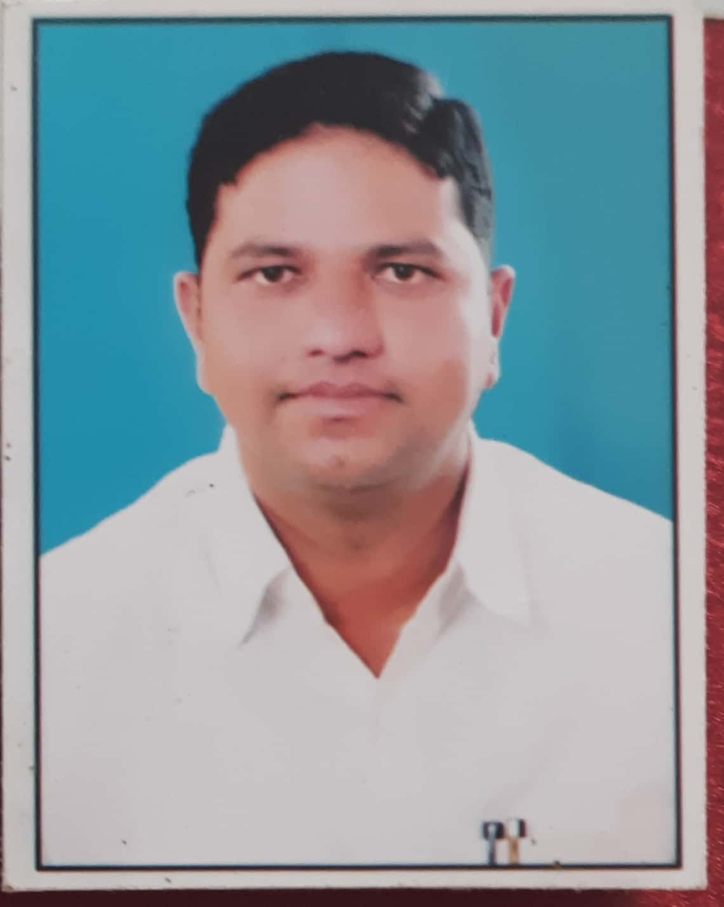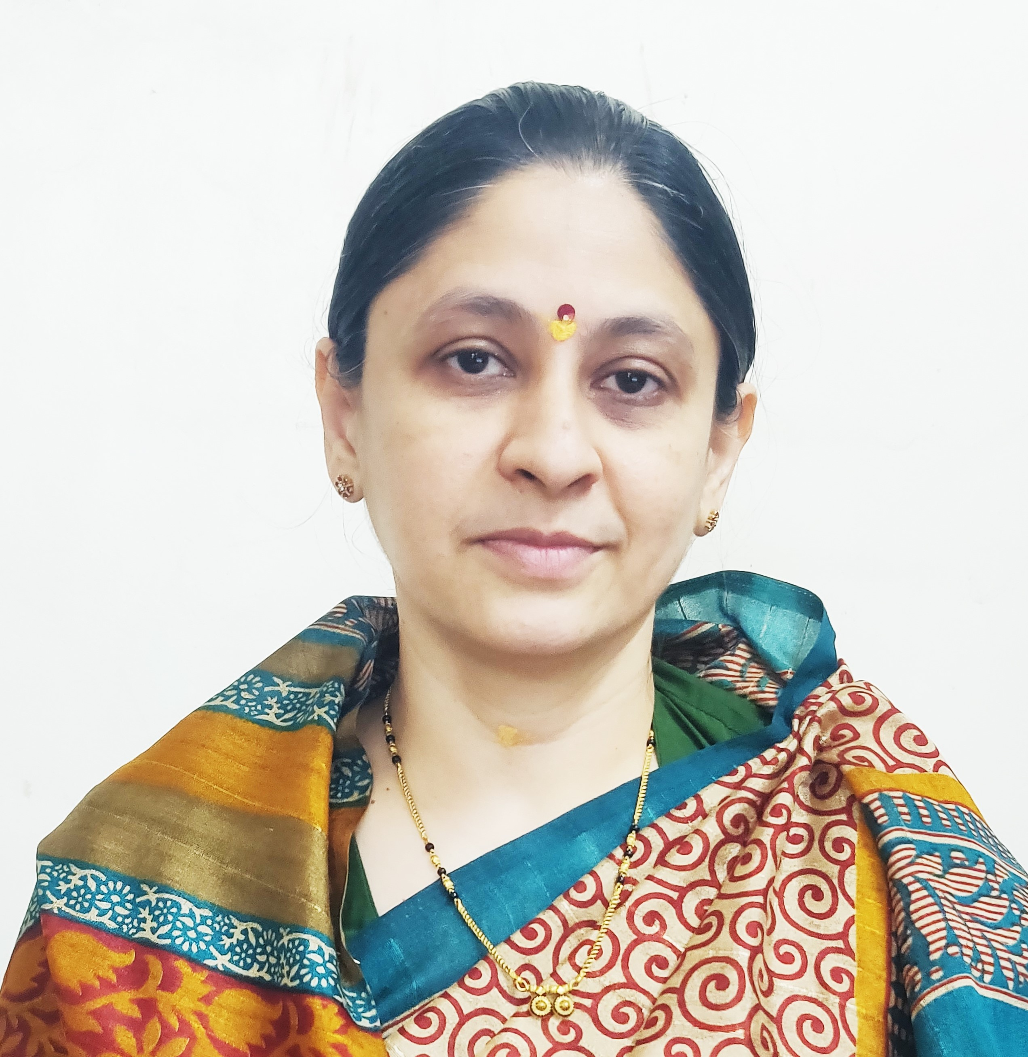
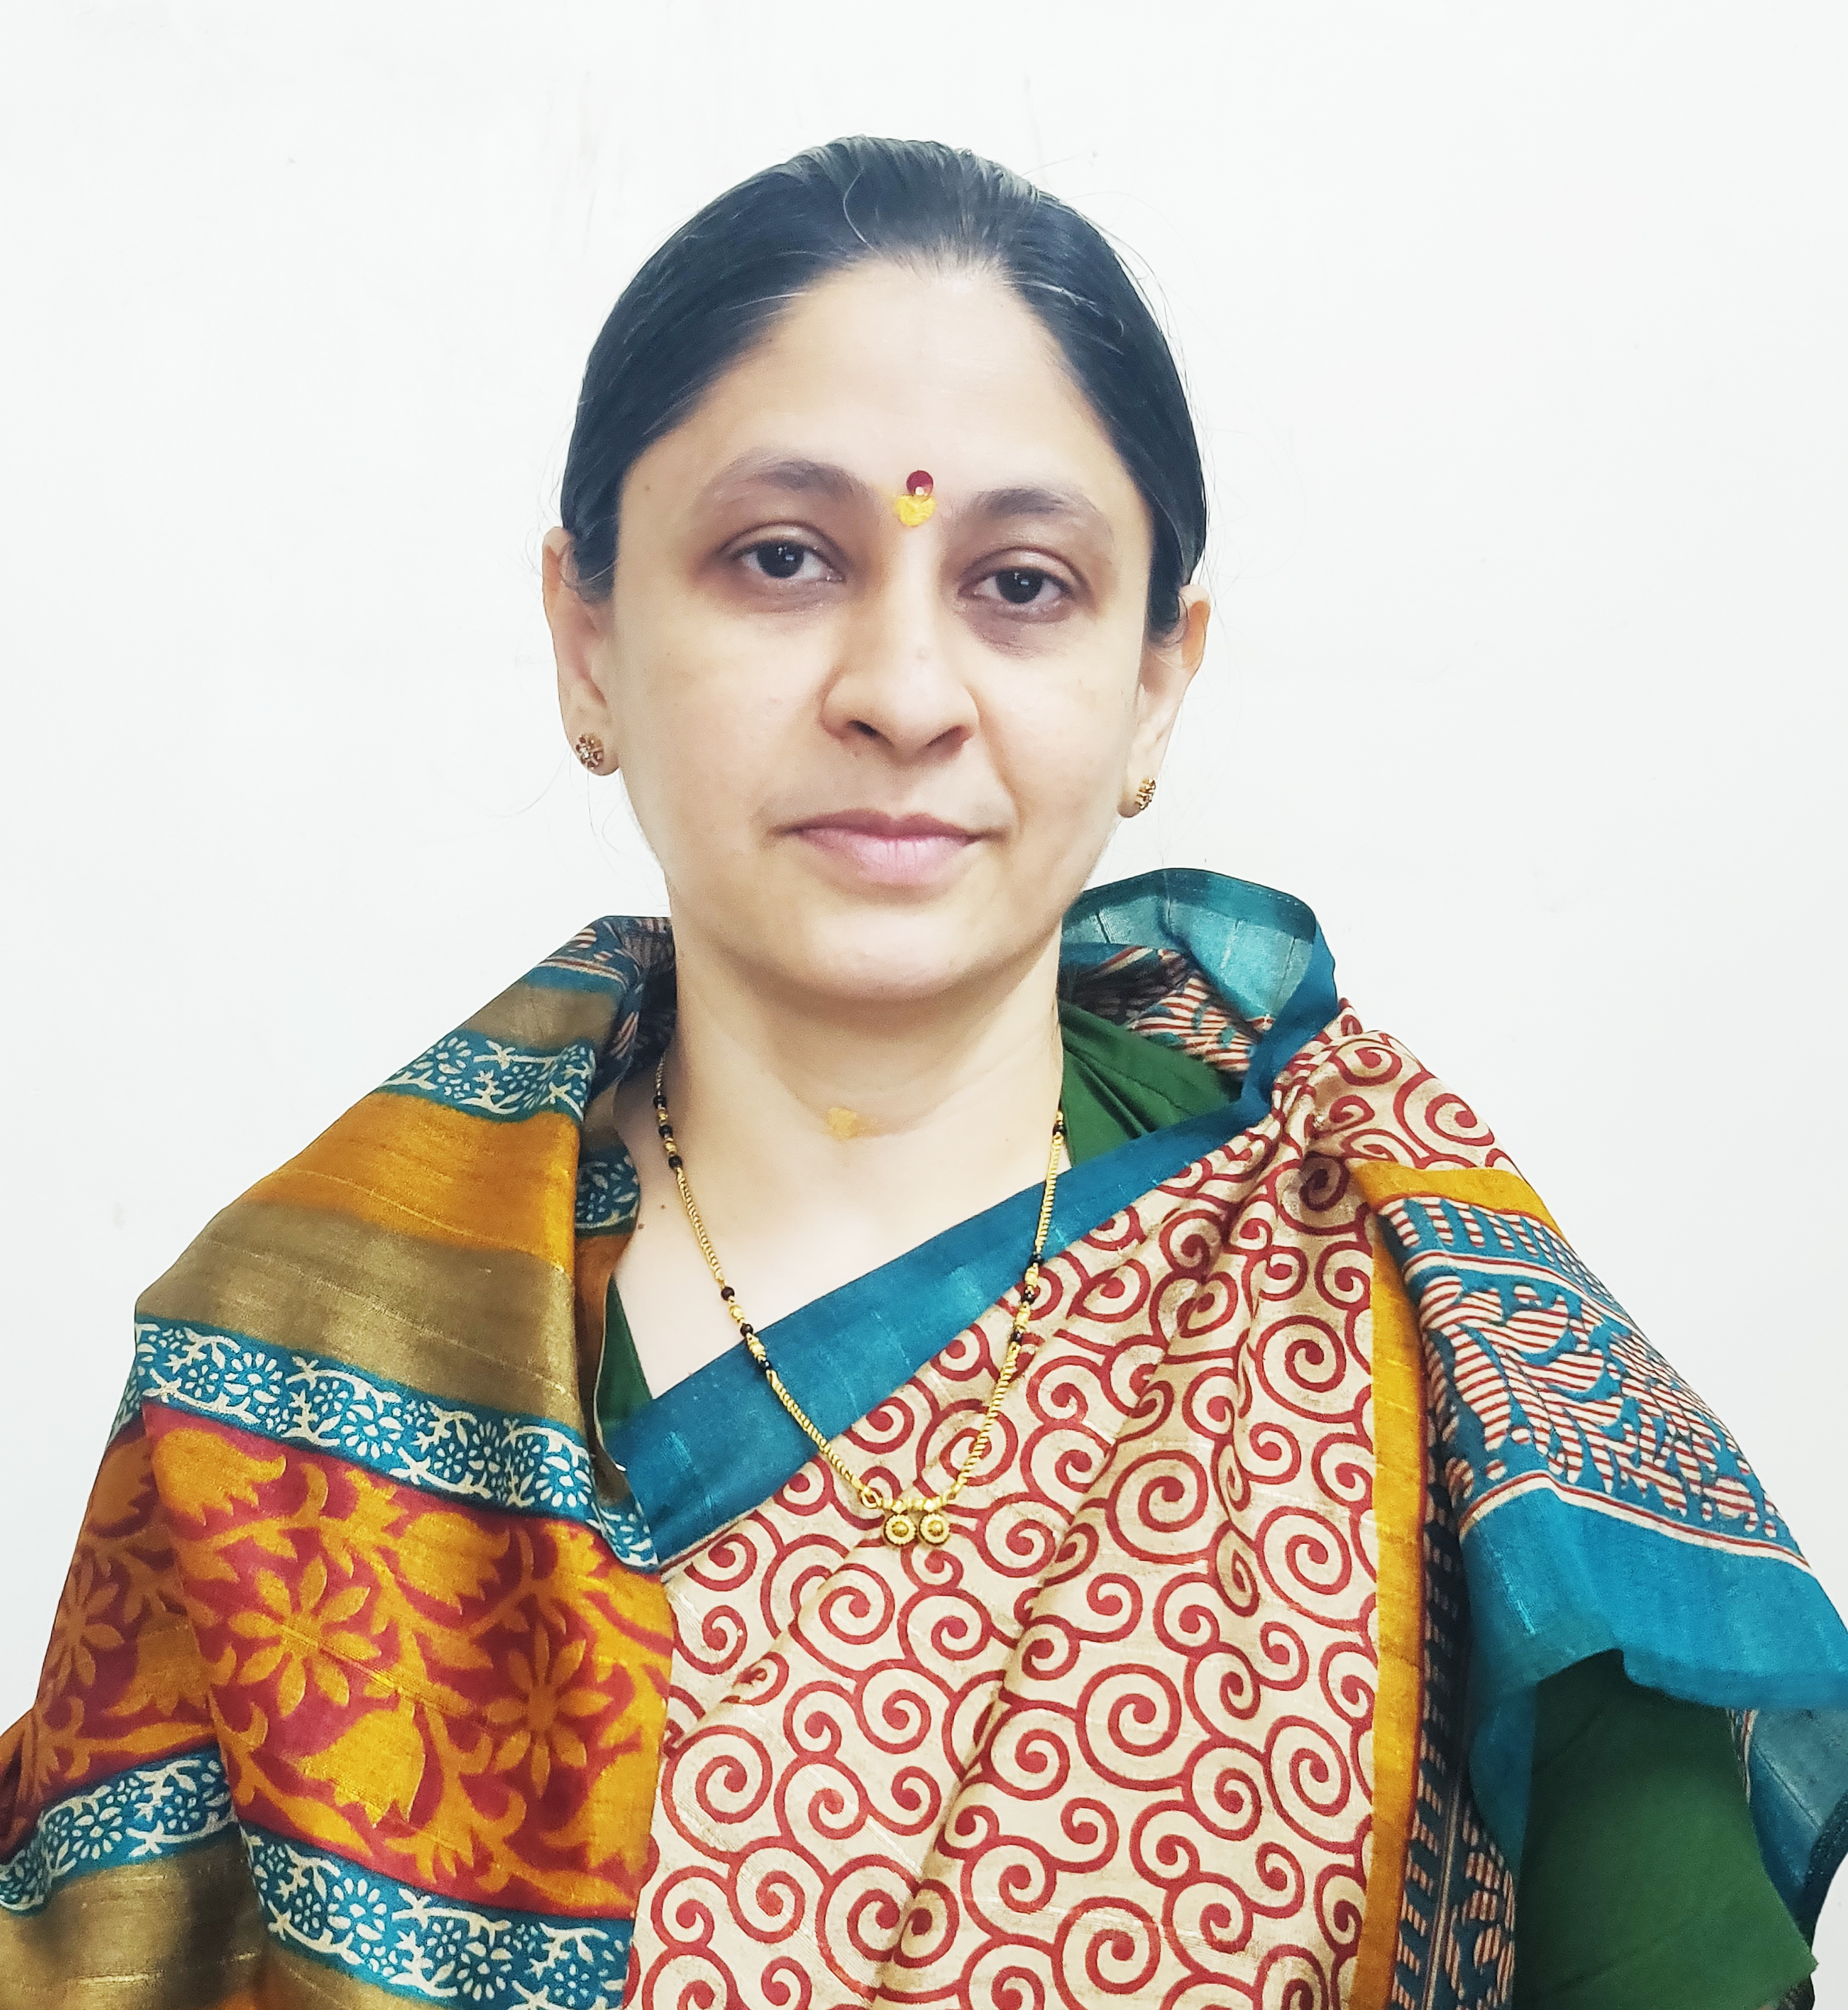

Photo
- General Information:

  - Name : Mr. Arun Parasram Kadam
  - Designation : Assistant Professor in Commerce

  - Date of Birth : 09th Sepetember 1988
  - Educational Qualifications: M. com, SET (Commerce), MA Economics ,MBA, GDC&A B.ed.

  - Present Pay Scale : CHB Grantable
  - Subject : Commerce

  - Area of Specialization : Business Administration
  - E-mail Id : arunkadam777@gmail.com
  - PAN : BHDPK8212P
  - Phone No. : 9823972556
  - B.C.U.D. Profile Username: 52092400134
  - HRMS Employee Code : NA

  - Permanent Address : At Post Padhegaon, Kopargaon , Taluka
  - Aadhar Card Number : 5312-0849-4103
- Academic Qualifications:

Degree | Board/University | YearofPassing | % of Marks
S.S. C. | Maharashtra Board | 2004 | 52.40%
H.S.C. | Maharashtra Board | 2006 | 61.17%
B.Com. | University of Pune | 2009 | 61.41%
M. Com. | University of Pune | 2012 | 61.50%
B.Ed. | University of Pune | 2012 | 63.75%
SET (Commerce) | SPPU | 2024 | Qualified
MBA | YCMOU | 2017 | 50.09%
MA Economics | SPPU | 2015 | 56.81%
GDC&A | Maharashtra Government | 2011 | 57.50%

- Teaching Experience (Commerce):

Date of Appointment in Rayat Shikshan Sanstha, Satara | Teaching Experience  (Years) | Research Experience  (Years)
08-10-2024 | 01 Year | NA
- Details of Services in Sanstha:

Sr.  No. | Name of the College | Period of Service
Sr.  No. | Name of the College | From | To
1. | C. D. Jain College of Commerce, Shrirampur | 08-10-2024 | Till Date

- Training Programmes attended: (Orientation/ Refresher/ Short Term Courses/ Faculty Development Courses)
Sr.  No. | Theme of Course | Organised by | Duration
1. | Faculty Development Programme in Artificial Intelligence | C. D. Jain College of Commerce, Shrirampur | 16th June, 2025 to 21st June, 2025

- Lectures Delivered:-

Sr.  No. | Topic of Lecture | Organised by | Programme
1. | Awareness about NEP 2020 | C. D. Jain College of Commerce, Shrirampur - Mahale Kanishtha Mahavidyalay, Ainatpur – (Faculty Exchange Programme) | School Connect 2.0 (Faculty Exchange Programme)

- Any Other Information
  - NAAC Criterion VI – Member
  - TYBCOM Admission Committee – Member.
I hereby declare that all the information given above is true to the best of my knowledge.

Arun Parasram Kadam
DATE: 10th July, 2025 NAME OF THE TEACHER

