Curriculum Vitae/ Profile
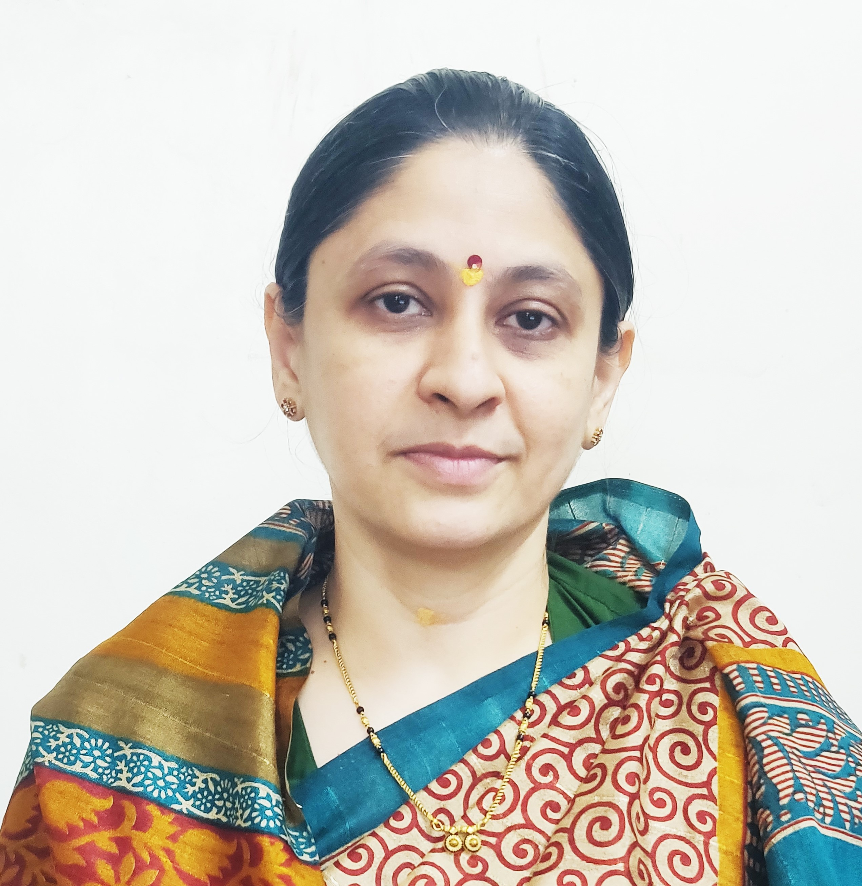
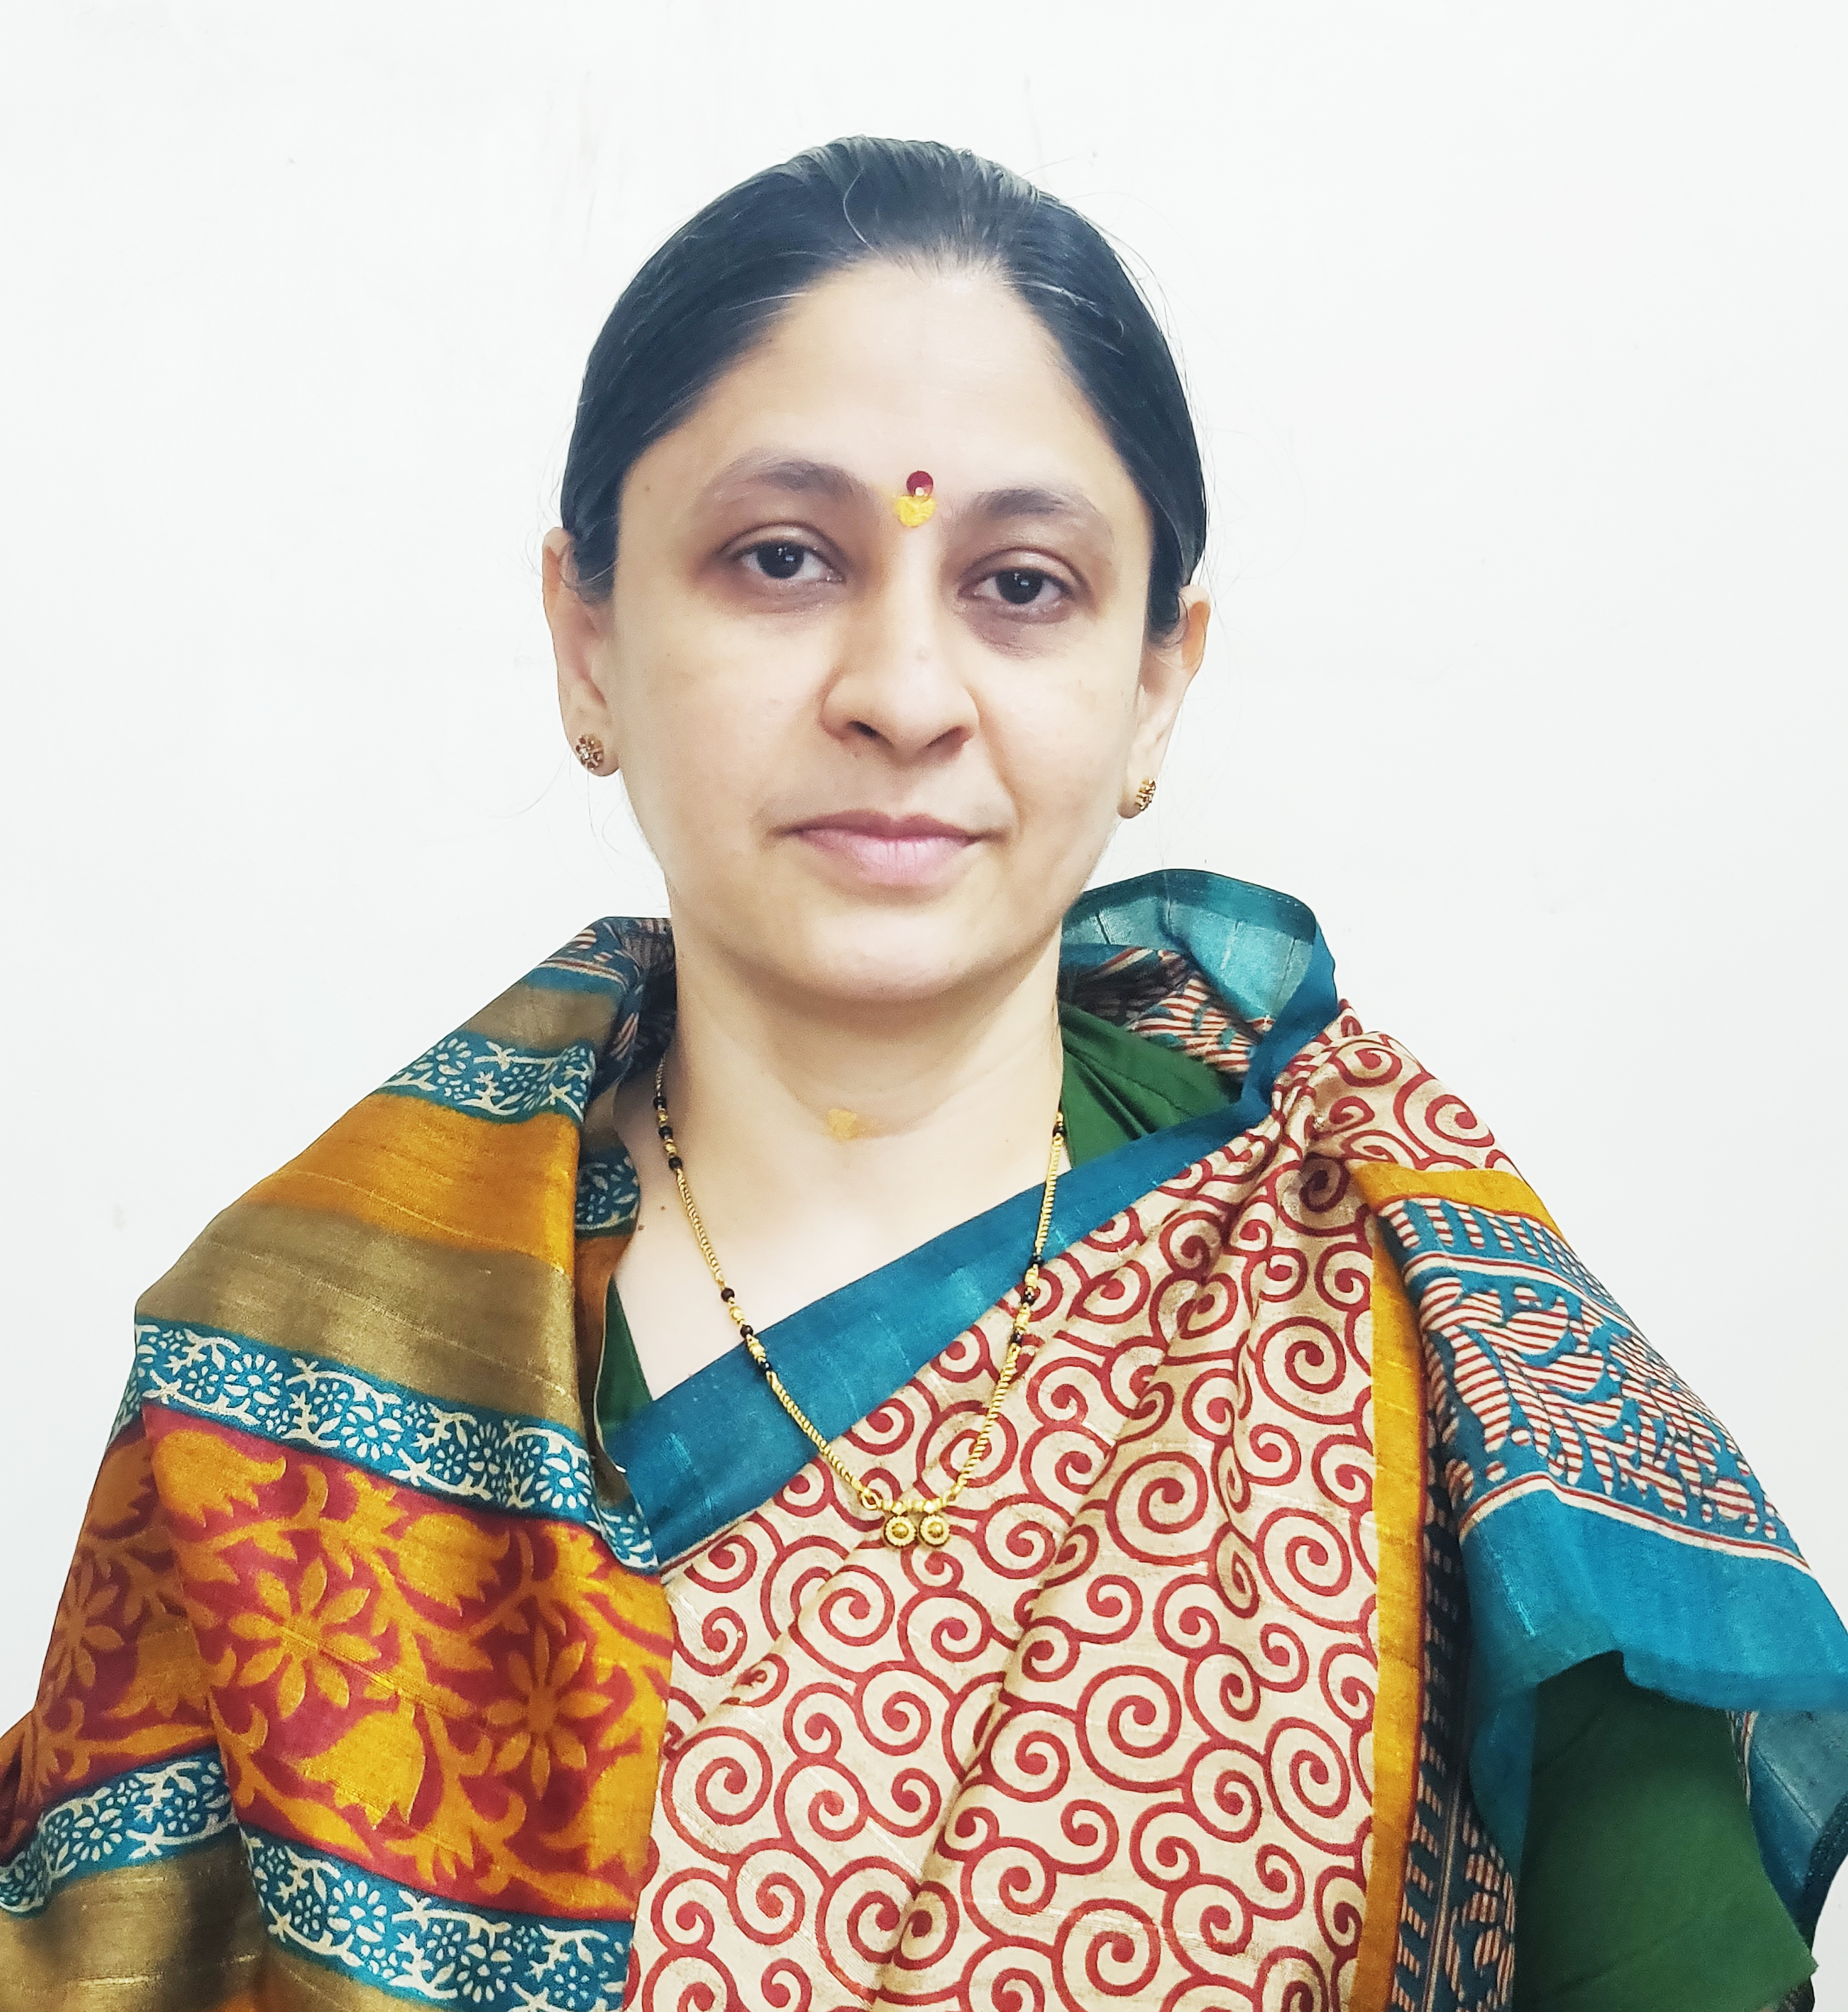

Photo
- General Information:

  - Name : Mr.Yogesh Rajabapu Labade.
  - Designation : Assistant Professor in Commerce

  - Date of Birth : 5th October, 1992
  - Educational Qualifications: M. com, SET (Commerce).

  - Present Pay Scale : CHB Grantable
  - Subject : Commerce

  - Area of Specialization : Business Administration
  - E-mail Id : ylabade510@gmail.com
  - PAN : ATGPL0147E
  - PhoneNo. : 8698927263
  - B.C.U.D. Profile Username: 52081800349
  - HRMS Employee Code : NA

  - Permanent Address : At- Madaki, Tal- Newasa, Dist-Ahilyanagar.
  - Aadhar Card Number : 2965 9865 2177.
- Academic Qualifications:

Degree | Board/University | Year of Passing | % of Marks
S.S. C. | Maharashtra Board | 2008 | 64.00%
H.S.C. | Maharashtra Board | 2010 | 52.67%
B.Com. | University of Pune | 2014 | 65.75%
M. Com. | University of Pune | 2017 | 72.69%
SET (Commerce) | SPPU,Pune | 2018 | Qualified

- Teaching Experience (Commerce):

Date of Appointment in Jijamata college of science and arts bhende.bk. | Teaching Experience  (Years) | Research Experience  (Years)
5th Jan 2018 | 7 Years | NA
- Details of Services in Sanstha:

Sr.  No. | Name of the College | Period of Service
Sr.  No. | Name of the College | From | To
1. | C. D. Jain College of Commerce, Shrirampur | 16th June, 2025 | Till Date

- Research Papers Published:

S.N. | Title of the Paper | Journal | Issue | ISSN No | Page No. | Citations
1 | Study of Digital Payment System in India | AJANTA Journal | I-jan march 2019 | 2277-5730 | 82-85 | Impact Factor – 5.5
2 | A Study of E-Commerce in India | Vidyawarta. | Special issue jan 2019 | 2319-9318 | 112-114 | Impact Factor – 5.131(IIJIF)

- Training Programmes attended: (Orientation/ Refresher/ Short Term Courses/ Faculty Development Courses)

Sr.  No. | Theme of Course | Organised by | Duration
1. | Faculty Development Programme in Artificial Intelligence | C. D. Jain College of Commerce, Shrirampur | 16th June, 2025 to 21st June, 2025
2.

- Details of Seminars/Conference/Workshops/Symposia attended:
- SEMINARS:

Sr.  No. |  | Theme of Seminar/  Workshop | Organised by | Attended/  PresentedPaper | Level | Date
1 | Choice based credit System(CBCS) Implementation of commerce and Science Programs of Colleges affiliated to SPPU workshop |  | Savitribai Phule Pune University. | Attended | University | 14th Sept, 2019

- CONFERENCES:

Sr.  No. | Theme of Conference | Organised by | Attendance/  Presentation | Level | Date
1 | Recent Trends in Commerce and Management | Shri Dnyaneshwar Mahavidyalaya,Newasa | Attended | national Level | 15th to 16th Feb. 2019
2. | Innovative and Recent Trends in Commerce, Management and IT. | Arts Commerce and Science College, Sonai. | Attended | State | 22nd and 23rd Jan 2019

- Participation in Corporate life /Extension work/ Community Services:

Sr.No | Position held | Name of the Authority | From | To
1. | Co-ordinator member | NSS Jijamata College of science and arts, bhende. | 1st July, 2018 | 31st April 2025

- Any Other Information
  - NAAC Criterion II – Member.
  - T.Y.B.Com. 2019 Pattern (CBCS) Admission Committee – Member
I hereby declare that all the information given above is true to the best of my knowledge.

Mr.Y.R.Labade.
DATE: 7th July, 2025 NAME OF THE TEACHER

