Curriculum Vitae/ Profile
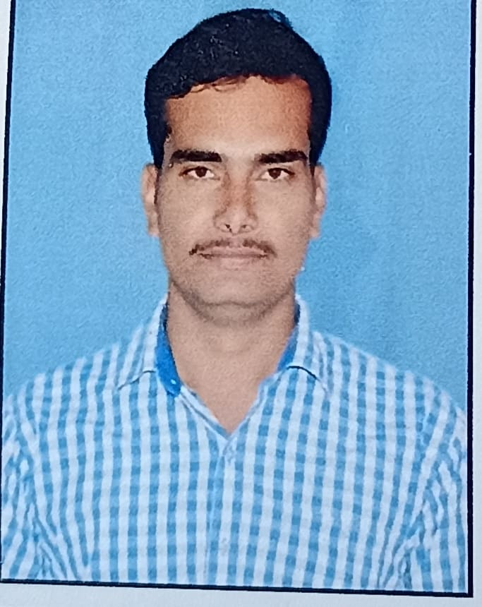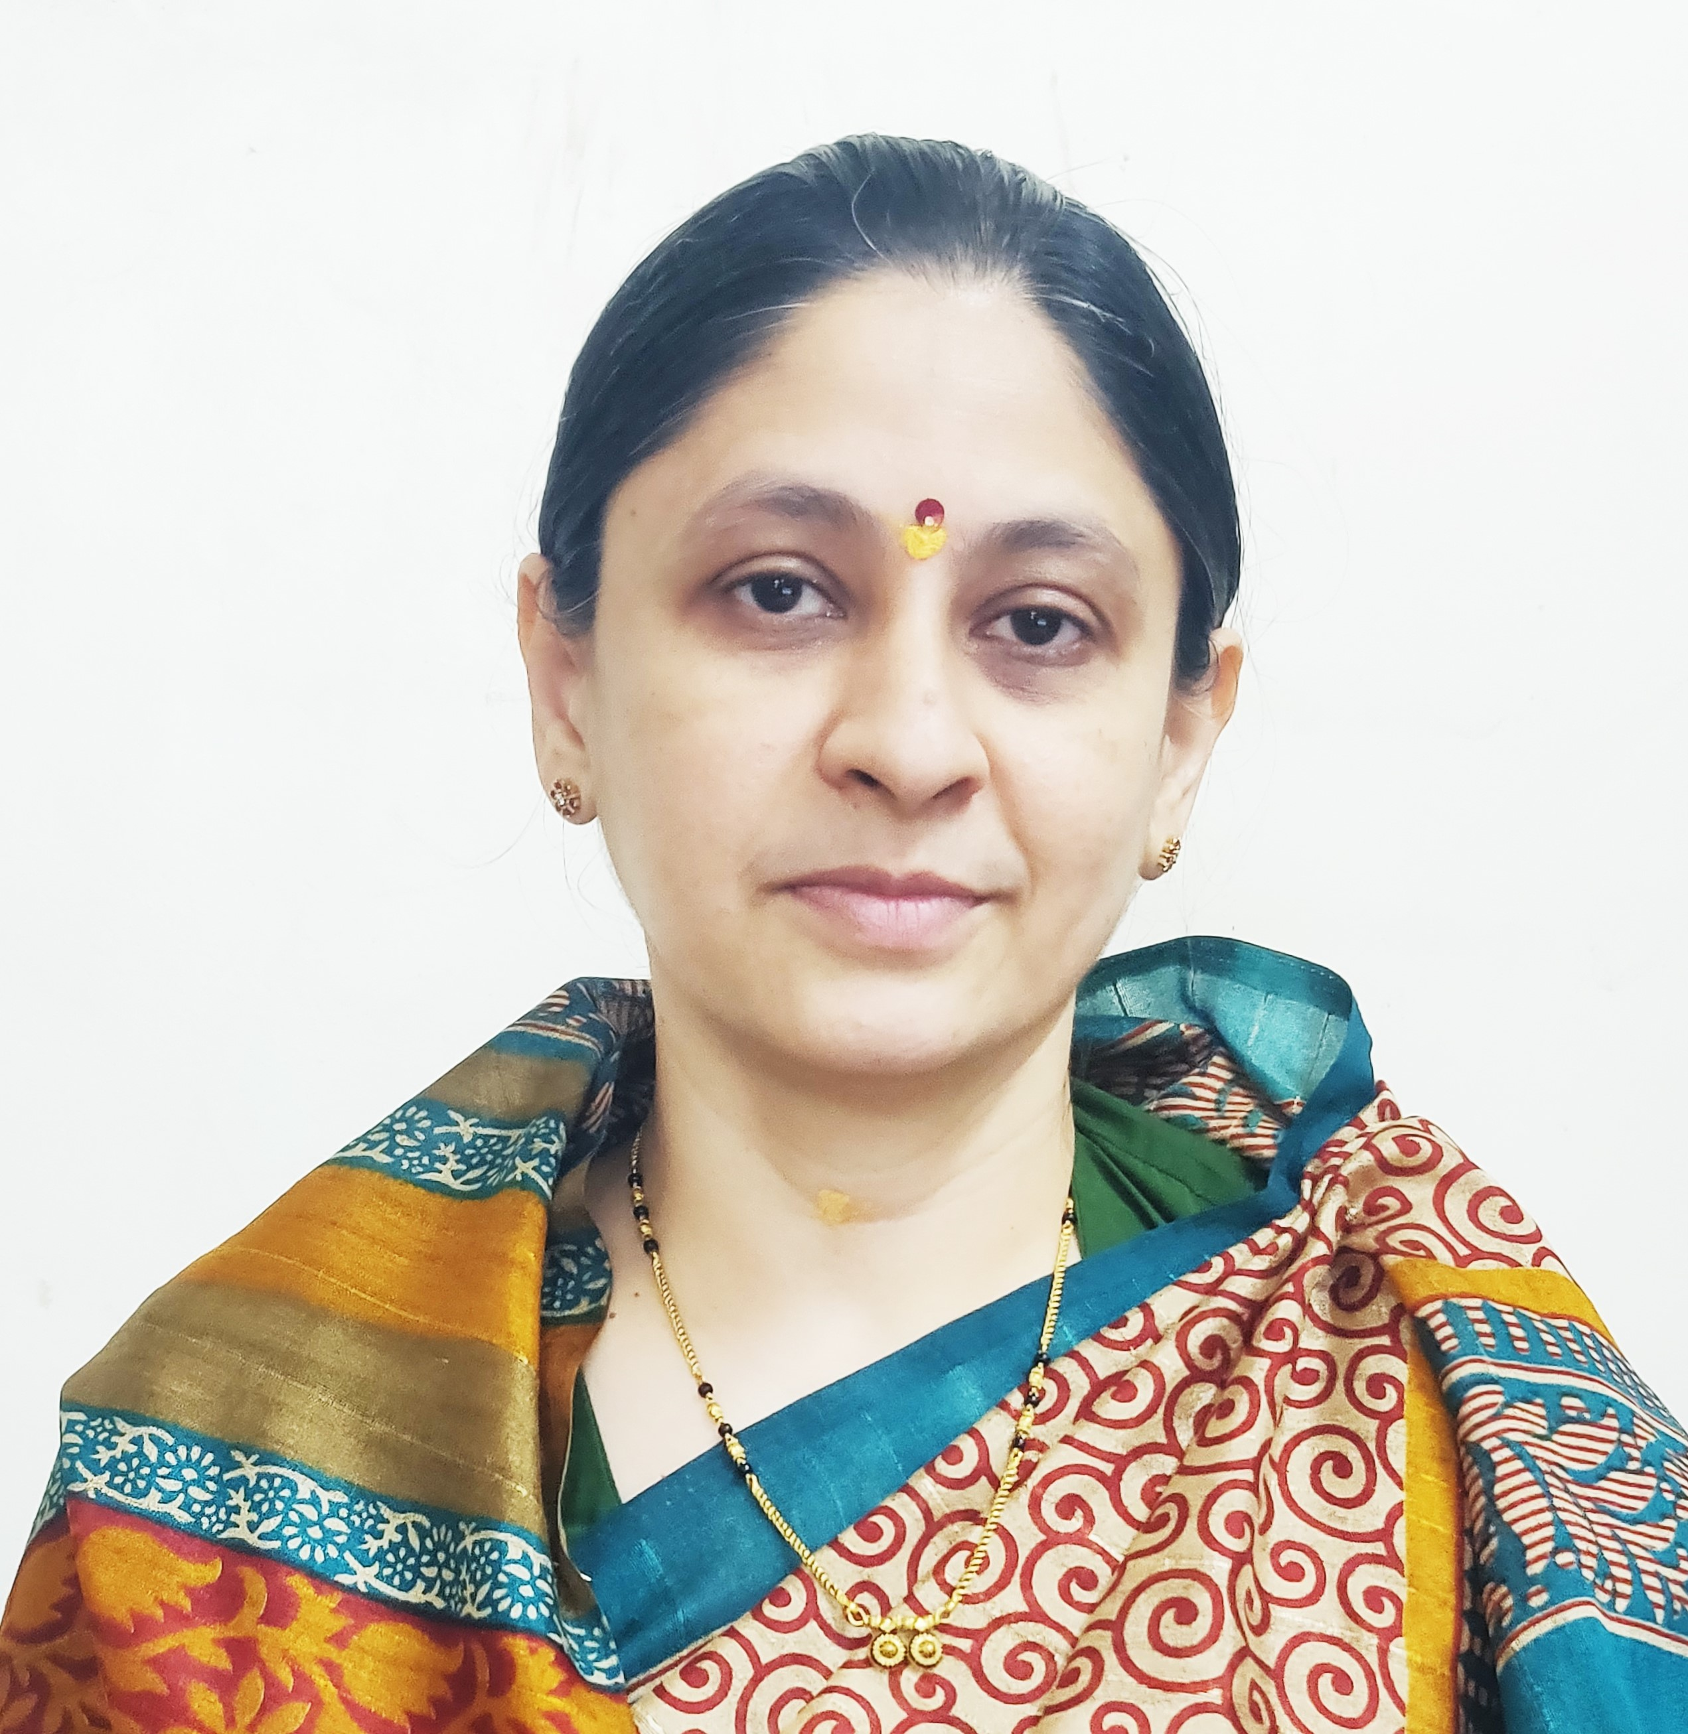
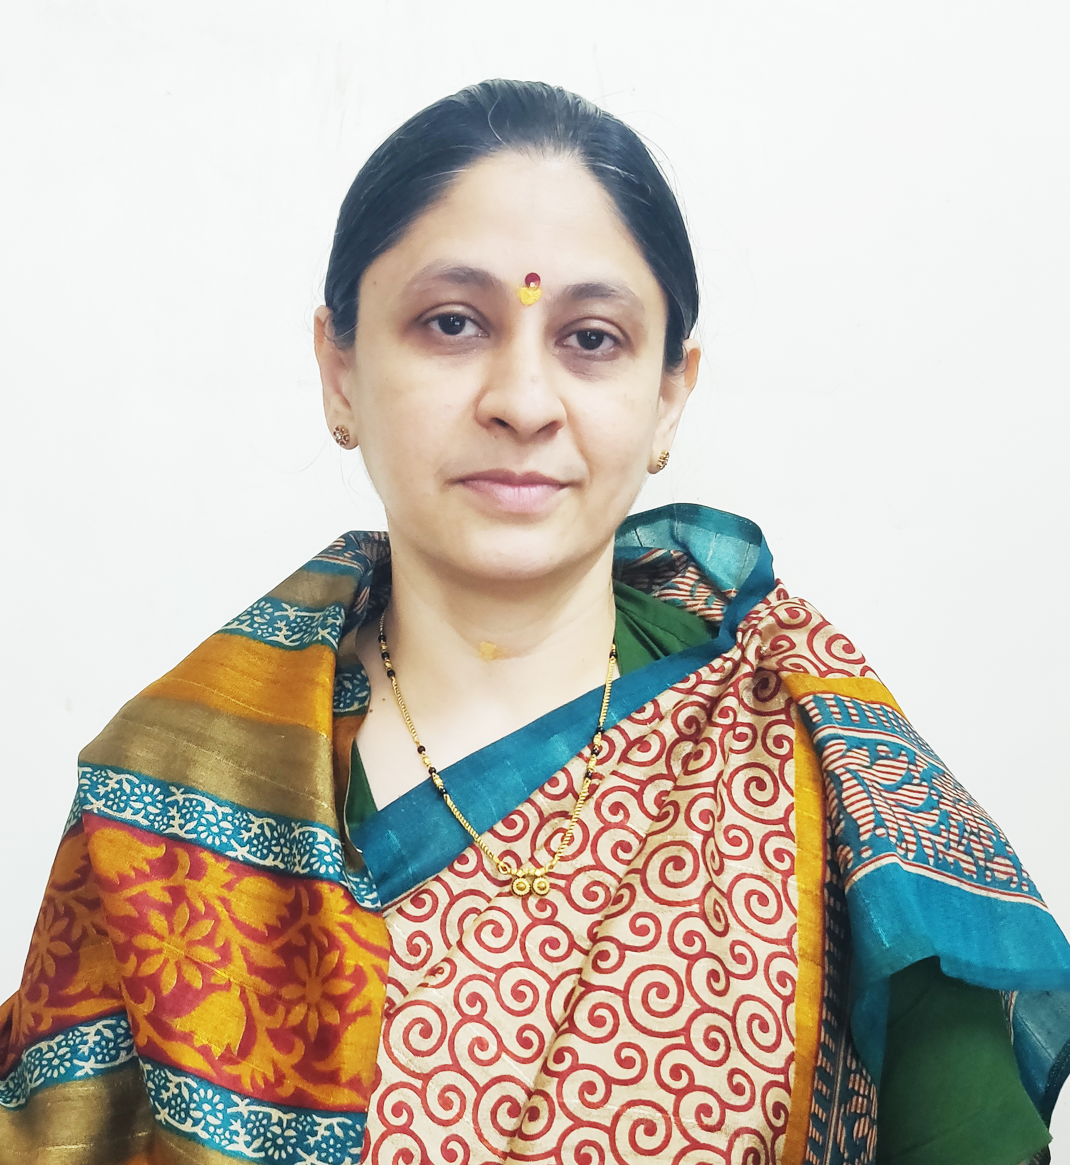

Photo
- General Information:

  - Name : Dr. Yadav Pradip Shardaprasad
  - Designation : Assistant Professor in Commerce

  - Date of Birth : 05th June 1994
  - Educational Qualifications: M. com, NET (Commerce), Ph. D.

  - Present Pay Scale : CHB Grantable
  - Subject : Commerce

  - Area of Specialization : Advanced Accounting and Taxation
  - E-mail Id : pradipyadav1994@gmail.com
  - PAN : AKHPY3491J
  - Phone No. : 9921770206
  - B.C.U.D. Profile Username: 52201691390
  - HRMS Employee Code : NA

  - Permanent Address : Yadavnagar ,Behind RBNB college,Ward No. 1, Shrirampur.

  - Aadhar Card Number : 4328-5533-4377
- Academic Qualifications:

Degree | Board/University | Year of Passing | % of Marks
S.S. C. | Maharashtra Board | 2009 | 64.61%
H.S.C. | Maharashtra Board | 2011 | 70.83%
B.Com. | University of Pune | 2014 | 72.91%
M. Com. | Savitribai Phule Pune University Pune | 2016 | 72.08%
NET (Commerce) | UGC | 2016 | Qualified
Ph.D. | Savitribai Phule Pune University Pune | 2024 | Awarded

- Teaching Experience (Commerce):

Date of Appointment in Rayat Shikshan Sanstha, Satara | Teaching Experience  (Years) | Research Experience  (Years)
08th August 2016 | 10 Years | NA
- Details of Services in Sanstha:

Sr.  No. | Name of the College | Period of Service
Sr.  No. | Name of the College | From | To
1. | SSGM College, Kopargaon | 08th August 2016 | 30th June 2020
2. | C. D. Jain College of Commerce, Shrirampur | 01th July, 2020 | Till Date

- Research Papers Published:
S.N. | Title of the Paper | Journal | Issue | ISSN No | Page No. | Citations
1 | Recruitment Needs of Companies and Importance of Campus Recruitment | Research Journey International Multi-Disciplinary E-Research Journal – November 2018 | Special Issue -Samiksha | 2348-7143 | 208 | Impact Factor – 3.425
2 | The Study Role of Colleges in Students Labor Market Alignment | Akshay Kalit – Transforming Challenges in Business Opportunities – 29th to 30th March, 2022 | 9 | 2277-419X | 228 | -
3 | College Students Perceptions about College Education and Their Employability Skill | Education & Society – 27th – 28th January, 2023 | I/III | 2278-6864 | 231 | UGC Care Listed
4 | Strategic Role of Human Resources in Implementing NEP 2020: A Pathway to Institutional Excellence | International Journal of Economics, Business, Accounting, Agriculture and Management towards Paradigm Shift in Research (IJEBAMPSR) April 2025 | Volume 2| Issue 2 | 3065-9140 | 182 | UGC Care Listed

- Articles/ Chapters published in books:

Sr.  No. | Title with page no. | Journal | ISSN / ISBN | Impact Factor | Peer Reviewed | Citations
1 | शरदचंद्रजी पवार - समताधिष्ठित नेतृत्व- 57 | Desh Aani Videshatil Vividh Kshetratil Purush KartutwacheYogdaan- December, 2022 | 978-93-91033-77-4 | NA | NA | NA
2 | रतन टाटा - आधुनिक भारत निर्माणातील योगदान | The Contribution of National and International Personalities in The Making of Modern India February, 2025 | - | NA | NA | NA

- Training Programmes attended: (Orientation/ Refresher/ Short Term Courses/ Faculty Development Courses)

Sr.  No. | Theme of Course | Organised by | Duration
1. | Faculty Development Programme in Artificial Intelligence | C. D. Jain College of Commerce, Shrirampur | 16th June, 2025 to 21st June, 2025
2. | 19-NEP 2020 Orientation & Sensitization Programme | Dr Babasaheb Ambedkar Marathwada University, Chhatrapati Sambhajinagar, UGC-Malviya Mission Teacher Training Centre | 09-12-2024 to 18- 12-2024

- Details of Seminars/Conference/Workshops/Symposia attended:

- CONFERENCES:

Sr.  No. | Theme of Conference | Organised by | Attendance/  Presentation | Level | Date
1 | Akshay Kalit – Transforming Challenges in Business Opportunities | SSGM Science, Gautam Arts and Sanjivani Commerce College, Kopargaon | Attended | International Level Virtual Conference | 29th to 30th March 2022
2 | India @75: Sustainable Development through Commerce and Management | Karmveer Bhaurao Patil Mahavidyalaya, Pandharpur | Attended | International | 27th – 28th January, 2023
3 | Recent Trends in Commerce, Economics and Management (RTCEM 2025) | SSGM Science, Gautam Arts and Sanjivani Commerce College, Kopargaon | Presented | National level E- Conference | 18th March, 2025
- WORKSHOPS:

Sr.  No. | Theme of Seminar/ Workshop | Organized by | Capacity | Date
1 | One Day Workshop on Research Methodology | C. D. Jain College of Commerce, Shrirampur | One Day | 7th February, 2024
2 | One Day Workshop on NEP 2020 | C. D. Jain College of Commerce, Shrirampur | One Day | 25th June, 2024
3 | One Day Workshop on Research Methodology and Project Work | C. D. Jain College of Commerce, Shrirampur | One Day | 11th April 2025

- Papers Published in Conferences Proceedings:

S.N. | Name of the Conference | Title of the Paper | Level | ISSN No. | Place | Pg. No.
1 | Desh Aani Videshatil Vividh Kshetratil Purush KartutwacheYogdaan- December, 2022 | शरदचंद्रजी पवार - समताधिष्ठित नेतृत्व | 23rd International Interdisciplinary Conference, Pune | ISBN 978-93-91033-77-4 | Pune | 57
2 | The Contribution of National and International Personalities in The Making of Modern India February, 2025 | रतन टाटा - आधुनिक भारत निर्माणातील योगदान | 29th International Interdisciplinary Conference, Pune | - | Pune | -

- Participation in Corporate life /Extension work/ Community Services:

Sr.No | Position held | Name of the Authority | From | To
1. | Customer care Executive | Tata Business Supportive Service Ltd. | 01st November 2013 | 30th April 2014

- Lectures Delivered:-

Sr.  No. | Topic of Lecture | Organised by | Programme
1. | Awareness about NEP 2020 | C. D. Jain College of Commerce, Shrirampur – Jankirao Wamanrao Adik Vidyalay, Kahanpur – (Faculty Exchange Programme) | School Connect 2.0 (Faculty Exchange Programme)

- Any Other Information
  - NAAC Criterion X – Chairman.
  - Student Development Board – Coordinator.
  - S.Y.B.Com (NEP 2020) Admission Committee – Member.
I hereby declare that all the information given above is true to the best of my knowledge.

Dr Yadav P. S.
DATE: 10th July, 2025 NAME OF THE TEACHER

