Faculty Profile

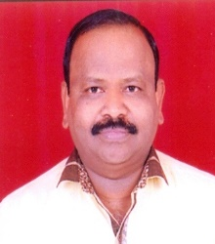

1 | Name : | Mr. Prafulla Manohar Dhavane
2 | Designation : | Librarian
3 | Address : | 11, Kamal Matrushri Row House, Chetnanagar  Nashik,Dist.Nashik - 422009
4 | DateofBirth : | 01June,1968
5 | MobileNo. : | 8275318377
6 | EmailAddress : | prafulladhavane@gmail.com
7 | AadharNumber : | 8016 5535 7998
8 | PANNumber : | AEIPD3599M
9 | EducationalQualification :

S.N. | Nameof Exam | University | PassingYear
1 | M.Lib. & I. Sci. | Dr. BabasahebAmbedkarMarathwada University, ChatrapatiSambhajinagar | 1997
2 | M. Phil. | Madurai kamraj University , Madurai | 2008

10 Experience :
1 | 24 years | 9 Months

11 Seminar/ConferenceAttendedandResearchPaperPresentedResourcePerson
Level | Attended | ResearchPaperPresented | ResourcePerson
InternationalLevel | 10 | 10 | --
NationalLevel | 6 | 6 | --
StateLevel | 5 | 00 | --
Total | 21 | 16 | --

12TotalNo'sofResearchPapers :Published
◾ | InJournalsbearingISSN | 16
◾ | In Conferences/SeminarsProceedingsbearingISBN | 22

